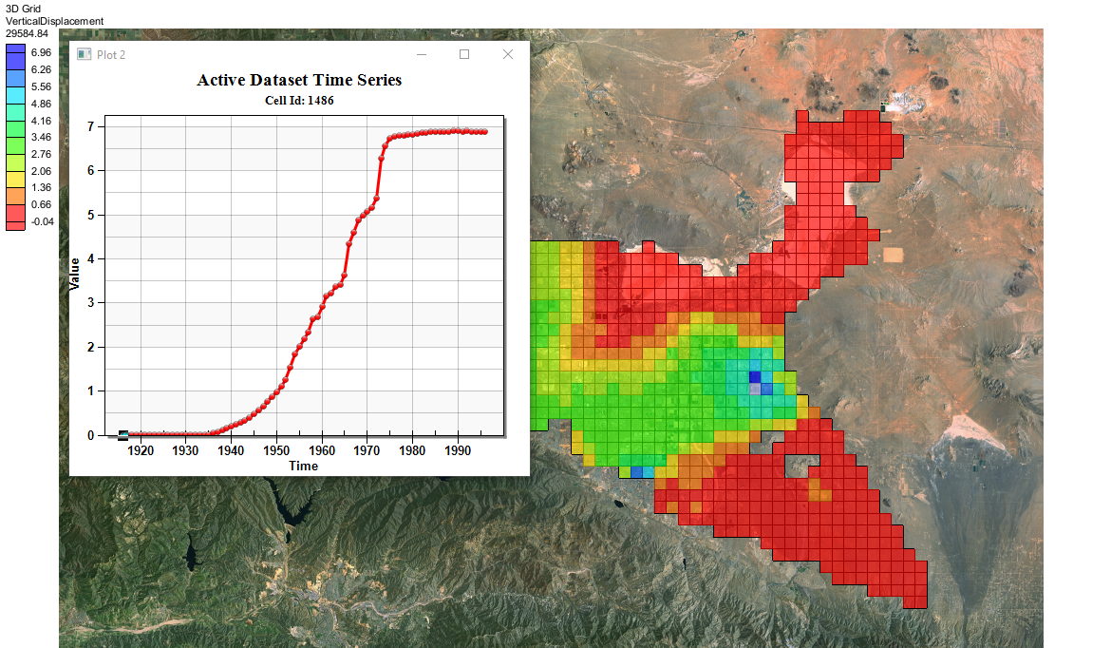

GMS 10.9

GMS 10.9 Tutorial

***MODFLOW – SUB Package***

The MODFLOW SUB Package Interface in GMS

Objectives

This tutorial demonstrates how to use the MODFLOW SUB package interface in GMS.

Time

* 40–60 minutes

Required Components

* GMS Core
* MODFLOW Interface

Prerequisite Tutorials

* MODFLOW – Conceptual Model Approach I

|  |
| --- |
| 1 Introduction 2  2 Getting Started 3  2.1 Importing the Project 3  2.2 Saving the Model with a New Name 4  3 Adding the SUB Package Using the Grid Approach 4  3.1 Enabling the SUB Package 4  3.2 Adding No-Delay Interbeds 4  3.3 Adding Delay Interbeds 5  3.4 Additional Options 6  3.5 Enabling Vertical Displacement Output 6  3.6 Saving and Running MODFLOW 6  3.7 Examining the Solution 7  4 Building a Conceptual Model 8  4.1 Importing and Renaming the Original Model 8  4.2 Creating the Conceptual Model 8  4.3 Creating Layer 1 Coverage 9  4.4 Creating the Polygon 9  4.5 Setting Layer 1 Polygon Properties 9  4.6 Creating Layer 2 Coverage 10  4.7 Setting Layer 2 Polygon Properties 10  5 Mapping to MODFLOW 10  5.1 SUB Package Array Values 11  5.2 Saving and Running MODFLOW 12  5.3 Examine the Flow Budget 12  6 Conclusion 12 |

# Introduction

The Subsidence and Aquifer-System Compaction (SUB) Package was developed by the USGS to simulate aquifer compaction and land subsidence. The SUB package simulates compaction of interbeds, including both elastic (recoverable) and inelastic (not recoverable) compaction. It also includes the ability to simulate interbeds where drainage from the interbed is immediate (no-delay) or delayed.

The problem for this tutorial is illustrated in Figure 1. The model is based on a U.S. Geological Survey (USGS) model, which is described as follows:

Antelope Valley, California, is a topographically closed basin in the western part of the Mojave Desert, about 50 miles northeast of Los Angeles. The Antelope Valley ground-water basin is about 940 square miles and is separated from the northern part of Antelope Valley by faults and low-lying hills. Prior to 1972, ground water provided more than 90 percent of the total water supply in the valley; since 1972, it has provided between 50 and 90 percent. Most ground-water pumping in the valley occurs in the Antelope Valley ground-water basin, which includes the rapidly growing cities of Lancaster and Palmdale. …

The ground-water flow system consists of three aquifers: the upper, middle, and lower aquifers. The aquifers, which were identified on the basis of the hydrologic properties, age, and depth of the unconsolidated deposits, consist of gravel, sand, silt, and clay alluvial deposits and clay and silty clay lacustrine deposits. Prior to ground-water development in the valley, recharge was primarily the infiltration of runoff from the surrounding mountains. Ground water flowed from the recharge areas to the playas where it discharged either from the aquifer system as evapotranspiration or from springs. Partial barriers to horizontal ground-water flow, such as faults, have been identified in the ground-water basin. Water-level declines owing to ground-water development have eliminated the natural sources of discharge, and pumping for agricultural and urban uses have become the primary source of discharge from the ground-water system. Infiltration of return flows from agricultural irrigation has become an important source of recharge to the aquifer system.[1]

The model has been discretized into a grid that consists of 43 rows, 60 columns, and three layers. Each layer corresponds to the three aquifers. The simulation covers an 80 year period—from 1915 through 1995—with the first year being steady-state.

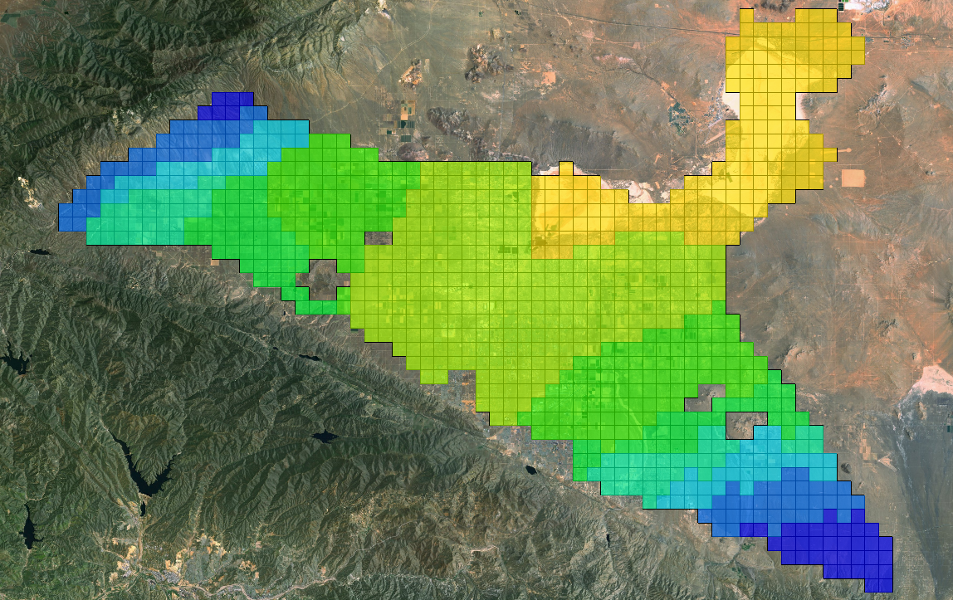

Figure 1 MODFLOW model for Antelope Valley

This tutorial will discuss and demonstrate adding the SUB package to an existing simulation using the grid approach, and creating a simple conceptual model to illustrate how the SUB package can be modeled conceptually and mapped to MODFLOW.

# Getting Started

Do the following to get started:

1. If necessary, launch GMS. If GMS is already running, select *File |* **New** to ensure that the program settings are restored to their default state.
2. Click **Don’t Save** if asked to save changes.

## Importing the Project

First, import the project:

1. Click **Open** File:Open Macro.svg to bring up the *Open* dialog.
2. Select “Project Files (*.gpr)” from the *Files of type* drop-down
3. Browse to the *sub\sub* folder and select “start.gpr”.
4. Click **Open** to import the project and exit the *Open* dialog.

A MODFLOW model similar to that in Figure 1 should appear.

## Saving the Model with a New Name

Before making changes, save the model with a new name.

1. Select *File |* **Save As…** to bring up the *Save As* dialog.
2. Select “Project Files (*.gpr)” from the *Save as type* drop-down.
3. For the *File name,* enter “avgrid.gpr”.
4. Click **Save** to save the project under the new name and close the *Save As* dialog.

# Adding the SUB Package Using the Grid Approach

Begin by adding the SUB package using the grid approach.

## Enabling the SUB Package

The first step is to turn on the SUB package by doing the following:

1. Select *MODFLOW |* **Global Options…** to open the *MODFLOW Global/Basic Package* dialog.
2. Click **Packages…** to open the *MODFLOW Packages / Processes* dialog.
3. In the *Optional packages / processes* section, turn on *SUB – Subsidence*.
4. Click **OK** to exit the *MODFLOW Packages / Processes* dialog.
5. Click **OK** to exit the *MODFLOW Global/Basic Package* dialog.

## Adding No-Delay Interbeds

Next, to add no-delay interbeds for the first and second model layers:

1. Select *MODFLOW | Optional Packages* **| SUB – Subsidence…** to open the *MODFLOW SUB Package* dialog.

The *Options* tab of the dialog contains general package values on the left, and delay interbed material zone values on the right. The *No Delay Interbeds* and *Delay Interbeds* tabs are used for creating interbeds and setting the interbed array values.

1. On the *No Delay Interbeds* tab, click **Insert Row** File:Insert Row Icon.svg twice to create two new interbed systems in the *No-delay interbed layers (LN)* spreadsheet.
2. On row *1,* in the *Layer* column, enter “1”.
3. On row *2,* in the *Layer* column, enter “2”.

The array values for a particular interbed system are shown by selecting an item in the desired system in the interbed layer spreadsheet.

1. In the *No-delay interbed layers (LN)* spreadsheet, select row *1* to show its values in the *HC for system* array editor on the right.
2. Click **2D Dataset → Array** to bring up the *Select Dataset* dialog.
3. In the *Solution* section, select the “Preconsolidated Head” dataset and click **OK** to exit the *Select Dataset* dialog.
4. From the *View/Edit* drop-down, select “(Sfe) Elastic skeletal storage coef”.
5. Click **Constant → Array** to bring up the *Grid Value* dialog.
6. For *Constant value for grid,* enter “1.5e-4” then click **OK** to exit the *Grid Value* dialog.
7. From the *View/Edit* drop-down, select “(Sfv) Inelastic skeletal storage coef”.
8. Click **Constant → Array** to bring up the *Grid Value* dialog.
9. For *Constant value for grid,* enter “8.0e-3” and click **OK** to exit the *Grid Value* dialog.
10. In the *No-delay interbed layers (LN)* spreadsheet, select row *2*.
11. From the *View/Edit* drop-down, select “(HC) Preconsolidation head or stress (ft)”.
12. Repeat steps 6–13, for the “(Sfe) Elastic skeletal storage coef” entering “9.0e-5”, and for the “(Sfv) Inelastic skeletal storage coef” entering “5.0e-3”.

## Adding Delay Interbeds

Now to add delay interbeds for the first and second layers:

1. On the *Delay Interbeds* tab, click **Insert Row** File:Insert Row Icon.svg twice to create two new interbed systems in the *Delay interbed layers (LDN)* spreadsheet.
2. In the *Layer* column, for row *1* enter “1” and for row *2* enter “2”.
3. In the *Delay interbed layers (LDN)* spreadsheet, select row 1.
4. From the *View/Edit* drop-down, select “(RNB) nequiv and areal extent”.
5. Click **Constant → Array** to bring up the *Grid Value* dialog.
6. For the *Constant value for grid,* enter “1.0” and click **OK** to close the *Grid Value* dialog.
7. From the *View/Edit* drop-down, select “(DZ) bequiv equivalent thickness (ft)”.
8. Click **Constant → Array** to bring up the *Grid Value* dialog.
9. For the *Constant value for grid,* enter “5.5” and click **OK** to close the *Grid Value* dialog.
10. From the *View/Edit* drop-down, select “(NZ) Material zone numbers”.
11. Click **Constant → Array** to bring up the *Grid Value* dialog.
12. For the *Constant value for grid,* enter “1” and click **OK** to close the *Grid Value* dialog.
13. From the *View/Edit* drop-down, select “(Dstart) Starting head in interbeds (ft)”.
14. Click **2D Dataset → Array** to bring up the *Select Dataset* dialog.
15. From the *Solution* section, select “Starting Head 1” and click **OK** to close the *Select Dataset* dialog.
16. From the *View/Edit* drop-down, select “(DHC) Starting preconsolidation head (ft)”.
17. Click **2D Dataset → Array** to bring up the *Select Dataset* dialog.
18. From the *Solution* section, select “Preconsolidated Head” and click **OK** to close the *Select Dataset* dialog.
19. Select row *2* in the *Delay interbed layers (LDN)* spreadsheet and repeat steps 4–18 using the values from the following table:

|  |  |  |  |  |  |  |
| --- | --- | --- | --- | --- | --- | --- |
| System | Layer | RNB | DZ | NZ | Dstart | DHC |
| 2 | 2 | 1.0 | 4.7 | 2 | Starting Head 2 | Preconsolidated Head |

## Additional Options

1. On the *Options* tab, in the *Number of Material Zones (NMZ)* field, enter “2”.
2. In the *Delay interbed material zone properties (DP)* spreadsheet, enter the following values:

|  |  |  |  |
| --- | --- | --- | --- |
| ID | Vertical K (ft/d) | Elastic spec. storage | Inelastic spec. storage |
| 1 | 1.0e-6 | 5.0e-6 | 6.0e-4 |
| 2 | 0.5e-6 | 5.0e-6 | 6.0e-4 |

## Enabling Vertical Displacement Output

Next to turn on the generation of vertical displacement data, which for layer 1, is the same as subsidence. The vertical displacement will be shown as a dataset in the MODFLOW solution.

1. Click **SUB Output Options…** to open the *MODFLOW SUB Package Output Options* dialog.
2. Click **Populate Time Steps…** to bring up the *Populate Time Steps* dialog.
3. From the drop-down, select “Specified output last time step each stress period” and click **OK** to close the *Populate Time Steps* dialog.
4. In the *All* row, scroll to the right in the spreadsheet and check the box in the *Save vert. disp. (Ifl8)* column.
5. Click **OK** to exit the *MODFLOW SUB Package Output Options* dialog.
6. Click **OK** to exit the *MODFLOW SUB Package* dialog.

## Saving and Running MODFLOW

Now it is possible to save the changes and run MODFLOW.

1. **Save** File:Save Macro.svg the project.
2. Click **Run MODFLOW** File:Run MODFLOW Macro.svg to bring up the *MODFLOW* model wrapper dialog.
3. When MODFLOW finishes, turn on *Read solution on exit* and *Turn on contours (if not on already)*.
4. Click **Close** to import the solution and close the *MODFLOW* model wrapper dialog.
5. **Save** File:Save Macro.svg the project with the new solution.

## Examining the Solution

Now it is possible to look more closely at the computed solution. First, to look at the flow budget entries for the SUB package:

### Flow Budget

1. Expand the “File:3D Grid Folder.svg 3D Grid Data” folder.
2. Under “http://www.xmswiki.com/w/images/b/b1/Tree_Folder_Lock.png avgrid (MODFLOW)”, select the “File:Dataset Cells Active.svg Head” dataset.
3. In the Time Step window, select the final time step.
4. Select *MODFLOW |* **Flow Budget…** to display the *Flow Budget* dialog.

The flow budget values for the SUB package include the *INST. IB STORAGE* and *DELAY IB STORAGE*. The values are approximately as shown in the table below. These values will be used to compare again later in the tutorial when building the same model using the conceptual approach.

|  |  |  |
| --- | --- | --- |
| **Type** | **Flow In** | **Flow Out** |
| **INST. IB STORAGE** | 298,086 | -6,406 |
| **DELAY IB STORAGE** | 149,747 | -1,210 |

1. Select **OK** to close the *Flow Budget* dialog.

### Viewing Vertical Displacement

1. Under “File:Generic Folder Locked.svg avgrid (MODFLOW)”, select “File:Dataset Cells Active.svg VerticalDisplacement”.
2. If necessary, scroll to the bottom of the Time Step window and select the last time step.

The vertical displacement in the model varies from near zero to as high as about 6.9 ft in cell ID 1486.

1. Switch between the “File:Dataset Cells Active.svg VerticalDisplacement” and “File:Dataset Cells Active.svg DrawDown” datasets and notice the similarities between the grid contours of the two datasets.

### Creating a Vertical Displacement Plot

Next to generate a plot that shows the vertical displacement for a single cell.

1. Select the “File:Dataset Cells Active.svg VerticalDisplacement” dataset in the Project Explorer.
2. Select *Grid |* **Find Cell…** to bring up the *Find Grid Cell* dialog.
3. For *Cell ID,* enter “1486”, and click **OK** to exit the *Find Grid Cell* dialog.

Cell 1486 will be selected in the Graphics Window.

1. Click **Plot Wizard** File:Plot Wizard Macro.svg to bring up the *Step 1 of 2* page of the *Plot Wizard* dialog.
2. In the *Plot Type* section, select “Active Dataset Time Series” from the list on the left.
3. Click **Finish** to close the *Plot Wizard* dialog.

The generated plot is shown in Figure 2. Again, switching back and forth between the “File:Dataset Cells Active.svg VerticalDisplacement” and “File:Dataset Cells Active.svg DrawDown” datasets in the Project Explorer shows there is a relationship between the two.

1. **Save** File:Save Macro.svg the project.

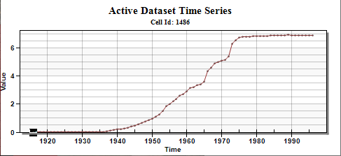

Figure 2 Vertical displacement plot for cell ID 1486

# Building a Conceptual Model

Next to use the conceptual model approach to add the same interbeds to the initial model.

## Importing and Renaming the Original Model

1. Select *File |* **New** to close the grid-based model and restore to defaults.
2. Select **Open** File:Open Macro.svg to bring up the *Open* dialog.
3. Select “Project Files (*.gpr)” from the *Files of type* drop-down.
4. Browse to the *sub\sub* folder and select “start.gpr”.
5. Click **Open** to import the project and exit the *Open* dialog.
6. Select *File |* **Save As…** to bring up the *Save As* dialog.
7. Select “Project Files (*.gpr)” from the *Save as type* drop-down.
8. Enter “avconc.gpr” as the *File name*.
9. Click **Save** to save the project under the new name and close the *Save As* dialog.

## Creating the Conceptual Model

1. In the Project Explorer, right-click in a blank spot and select *New |* **Conceptual Model…** to bring up the *Conceptual Model Properties* dialog.
2. For *Name,* enter “Antelope Valley”.
3. From the *Flow package* drop-down, select “BCF”.
4. Under *Advanced package options to include*, turn on *SUB – Subsidence.*
5. Click **OK** to close the *Conceptual Model Properties* dialog.

## Creating Layer 1 Coverage

1. Right-click on the “File:Conceptual Model Icon.svg Antelope Valley” conceptual model and select **New Coverage…** to bring up the *Coverage Setup* dialog.
2. For the *Coverage name,* enter “layer 1”.
3. In the *Areal Properties* column, turn on *SUB Delay Interbed* and *SUB Non-delay Interbed.*
4. Click **OK** to exit the *Coverage Setup* dialog.

## Creating the Polygon

1. Select the “File:Coverage Active Icon.svg layer 1” coverage to make it active.
2. Turn off “File:GIS Folder.svg GIS Layers” in the Project Explorer.
3. Using the **Create Arc** File:GMS Create Arc Tool.svg tool, create a quadrilateral arc surrounding the grid. End the arc on the beginning point to form a closed polygon (see Figure 3).
4. Select *Feature Objects |* **Build Polygons** to turn it into a polygon.

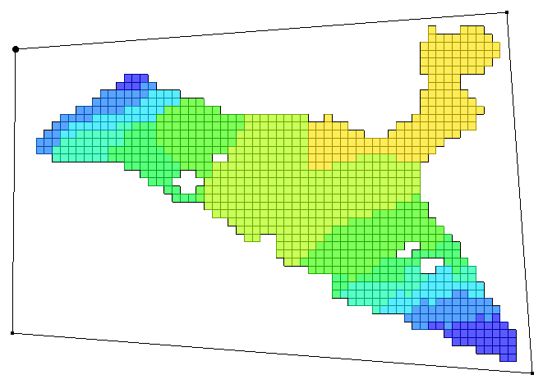

Figure 3 Creating a polygon that encompasses the model grid

## Setting Layer 1 Polygon Properties

1. Using the **Select Objects** File:Select Object Tool.svg tool, double-click anywhere inside the newly created polygon to bring up the *Attribute Table* dialog.
2. Enter the values from the right column in the table below into the fields indicated in the left column of the table. Leave all other properties at the default values.

|  |  |
| --- | --- |
| **SUB Sfe (elast. skel. st. coef, ND)** | 0.00015 |
| **SUB Sfv (inelast. skel. st. coef, ND)** | 0.008 |
| **SUB RNB (nequiv, D)** | 1.0 |
| **SUB DZ (bequiv equiv. thick., D) (ft)** | 5.5 |
| **SUB Vertical k (D) (ft/d)** | 1.0e-006 |
| **SUB Elastic spec. storage (D)** | 5.0e-006 |
| **SUB Inelastic spec. storage (D)** | 0.0006 |

1. Click **OK**to exit the *Attribute Table* dialog.

## Creating Layer 2 Coverage

1. In the Project Explorer, right-click on the “File:Coverage Active Icon.svg layer 1” coverage and select **Duplicate** to create the “File:Coverage Active Icon.svg Copy of layer 1” coverage.
2. Right-click on “File:Coverage Active Icon.svg Copy of layer 1” and select **Coverage Setup…** to bring up the *Coverage Setup* dialog.
3. For the *Coverage name,* enter “layer 2”.
4. Change the *Default layer range* to “2” to “2”.
5. Click **OK**to exit the *Coverage Setup* dialog.

## Setting Layer 2 Polygon Properties

1. Select “File:Coverage Active Icon.svg layer 2” to make it active.
2. Using the **Select Objects** File:Select Object Tool.svg tool, double-click anywhere inside the polygon to bring up the *Attribute Table* dialog.
3. Enter the values from the right column in the table below into the fields indicated in the left column of the table. Leave all other properties at the default values.

|  |  |
| --- | --- |
| **SUB Sfe (elast. skel. st. coef, ND)** | 0.00009 |
| **SUB Sfv (inelast. skel. st. coef, ND)** | 0.005 |
| **SUB RNB (nequiv, D)** | 1.0 |
| **SUB DZ (bequiv equiv. thick., D) (ft)** | 4.7 |
| **SUB Vertical k (D) (ft/d)** | 5.0e-007 |
| **SUB Elastic spec. storage (D)** | 5.0e-006 |
| **SUB Inelastic spec. storage (D)** | 0.0006 |

1. Click **OK**to exit the *Attribute Table* dialog.

# Mapping to MODFLOW

The conceptual model is set up so now it can be mapped to the MODFLOW grid.

1. Select *Feature Objects |* **Map → MODFLOW** to bring up the *Map → Model* dialog.
2. Click **OK** to accept the defaults and close the *Map → Model* dialog.

## SUB Package Array Values

Now it is possible to take a look at the data in MODFLOW that was mapped to the SUB package from the conceptual model.

1. Select *MODFLOW | Optional Packages |* **SUB – Subsidence…** to open the *MODFLOW SUB Package* dialog.

On the *Options* tab, note that two materials have been created in the *Delay interbed material zone properties (DP)* spreadsheet.

1. Select the *No Delay Interbeds* tab.
2. Switch between the different arrays using the *View/Edit* drop-down and the layer spreadsheet.

Note that the “(Sfe) Elastic skeletal storage coef” and “(Sfv) Inelastic skeletal storage coef” values have been properly mapped, and the “(HC) Preconsolidationhead or stress (ft)” values were mapped to the default value (0.0).

1. From the *View/Edit* drop-down, select “(HC) Preconsolidation head or stress (ft)”.
2. In the *No-delay interbed layers (LN)* spreadsheet, select row *1*.
3. Click **2D Dataset → Array** to bring up the *Select Dataset* dialog.
4. Select “Preconsolidated Head” and click **OK** to exit the *Select Dataset* dialog.
5. In the *No-delay interbed layers (LN)* spreadsheet, select row *2*.
6. Click **2D Dataset → Array** to bring up the *Select Dataset* dialog.
7. Select “Preconsolidated Head” and click **OK** to exit the *Select Dataset* dialog.

Now to set parameters in the *Delay Interbeds* tab:

1. Select to the *Delay Interbeds* tab.
2. From the *View/Edit* drop-down, select “(Dstart) Starting head in interbeds (ft)”.
3. In the *No-delay interbed layers (LN)* spreadsheet, select row *1*.
4. Click **2D Dataset → Array** to bring up the *Select Dataset* dialog.
5. Select “Starting Head 1” and click **OK** to close the *Select Dataset* dialog.
6. In the *No-delay interbed layers (LN)* spreadsheet, select row *2*, and repeat steps 14-15 choosing “Starting Head 2” as the dataset.
7. From the *View/Edit* drop-down, select “(DHC) Starting preconsolidation head (ft)”.
8. In the *No-delay interbed layers (LN)* spreadsheet, select row *1*.
9. Click **2D Dataset → Array** to bring up the *Select Dataset* dialog.
10. Select “Preconsolidated Head” and click **OK** to close the *Select Dataset* dialog.
11. In the *No-delay interbed layers (LN)* spreadsheet, select row *2,* and repeat steps 19–20.
12. Click **OK** to exit the *MODFLOW SUB Package* dialog.

## Saving and Running MODFLOW

Now it is possible to save the changes and run MODFLOW.

1. **Save** File:Save Macro.svg the project.
2. Select *MODFLOW |* **Run MODFLOW**to bring up the *MODFLOW* model wrapper dialog.
3. When MODFLOW finishes, turn on *Read solution on exit* and *Turn on contours (if not on already)*.
4. Click **Close** to close the *MODFLOW* model wrapper dialog.
5. **Save** File:Save Macro.svg the project with the new solution.

## Examine the Flow Budget

Now to review the computed solution more closely:

1. Expand the “File:3D Grid Folder.svg 3D Grid Data” folder.
2. In the Project Explorer, under the “File:Generic Folder Locked.svg avconc (MODFLOW)” folder, select the “File:Dataset Cells Active.svg Head” dataset.
3. In the Time Step window, select the last time step.
4. Select *MODFLOW |* **Flow Budget…** to display the *Flow Budget* dialog.

The flow budget should match the values previously observed when adding the SUB package using the grid method. The values are shown in the table below.

|  |  |  |
| --- | --- | --- |
| **Type** | **Flow In** | **Flow Out** |
| **INST. IB STORAGE** | 298,000 | -6,400 |
| **DELAY IB STORAGE** | 150,000 | -1,210 |

# Conclusion

This concludes the “MODFLOW – SUB Package” tutorial. The following key concepts were discussed and demonstrated:

* GMS supports the MODFLOW SUB package.
* SUB data can be entered and viewed in the *MODFLOW SUB Package* dialog.
* SUB data can be entered in a conceptual model and then mapped to a MODFLOW model.

1. Leighton, David A.; Phillips, Steven P. (2003). *Simulation of Ground-Water Flow and Land Subsidence, Antelope Valley Ground-Water Basin, California*. Water-Resources Investigations Report 03-4016. U.S. Geological Survey, p.1. <http://pubs.usgs.gov/wri/wrir034016/wrir034016.book.pdf>